Ministry of Education of the Republic of Moldova

Technical University of Moldova

Department of Software Engineering and Automatic

**REPORT**

*CDE*

Laboratory work No. 2

Performed by:

st. gr. FAF-161 Terman Emil

Verified by:

Prof. dr. hab. O. Lupan

(05 – 19.10.2017)



Chişinău - 2017

**The purpose of the work:** Study the process of rectification in the scheme of electronic single-phase rectification with semiconductor diodes. We observe the influence of the filters on the form and value of rectified voltage. We study the functioning of stabilizer with compensation (with a control element in derivation).

**Theory:**

*Power supply* – the device that transfers electric power from a source to a load using electronic circuits. It converts utility’s AC input power to a regulated voltage required for electronic equipment.

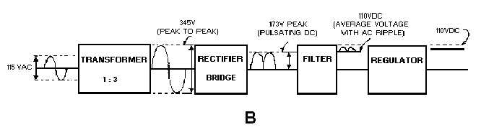

*Rectifier* – converts the AC input voltage to a pulsating DC voltage.

**Half wave rectifier**

When the sinusoidal input voltage goes positive, the diode is forward bias and conduct current through the load resistor.

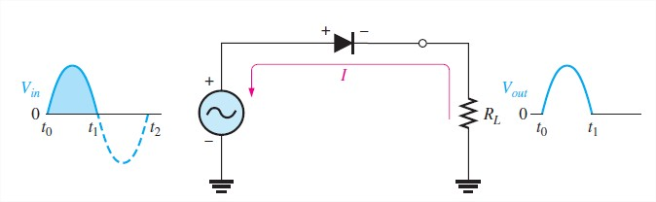

During the negative alternation of the input voltage, the current is 0, so the output is also 0,

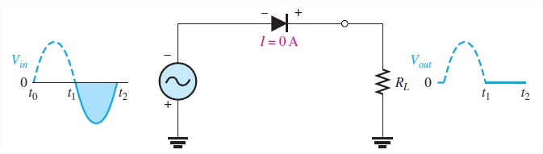

Half-Wave output voltage for four input cycles

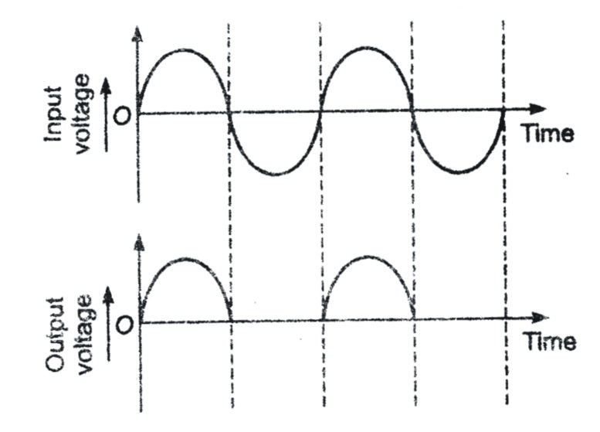

Center-tapped Full wave rectifier

Is a type of full-wave rectifier that uses 2 diodes connected to the secondary of a center-tapped transformer. For a positive half cycle of the input voltage the current path is through D1 and the load resistor.

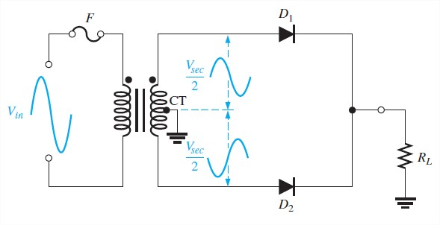

Bridge rectifier

It uses four diodes. When the input cycle is positive, diodes D1 and D2 are forward biased and conduct current. During the negative half-cycle of the input, D3 and D4 are forward biased and conduct current.

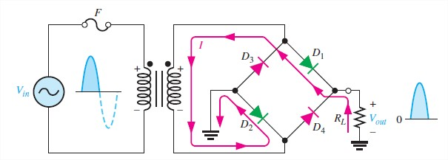

**Steps:**

1. We familiarize with the platform of the work, measuring devices and the sources of supply of the stand.
2. We compose the half-wave circuit without the filter. The measurements for other mountings are repeated:
   * Rectifier with filter „C” (interrupter *SA2* enclosed)
   * Rectifier with filter „L” (commutator *SA3* in position 2, SA2 opened)
   * Rectifier with filter „LC” of type „ך” (interrupter *SA4* enclosed, commutator *SA3* in position 2)
   * Rectifier with filter „LC” of type „ח” (interrupters *SA2, SA4* enclosed, commutator *SA3* in pos. 2)
   * Rectifier with filter „RC” of type „ך” (interrupter *SA4* enclosed, commutator *SA3* in position 1)
   * Rectifier with filter „RC” of type „ח” (interrupters *SA2, SA4* enclosed, commutator *SA3* in position 1).

The obtained data are written in table 3.1. The measurements are repeated for full-wave rectifier whose mounting is obtained due to enclosement of the interrupter *SA1*. The table 3.1 in which are introduced the obtained data is repeated

1. We increase the external characteristic of the half-wave rectifier on one figure and for full-wave rectifier in another figure.
2. We define inner resistance of the rectifier for both schemes.

(3.26)

1. We study the stabilizer of the voltage with discrete elements shown in figure 3.7.

**The Rectifiers schemes:**

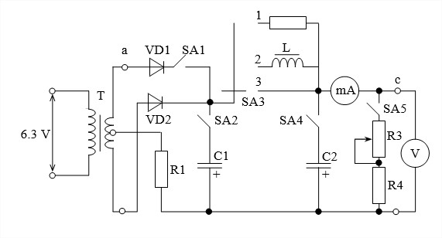

Fig. 1 The electrical scheme of a single-phase half-wave and full-wave rectifier for collecting of the output characteristics.

Fig. 3.7Electric scheme of the voltage stabilizer for studying of the properties of the stabilization.

**Experimental table**

Half wave rectifier:

|  |  |  |  |  |  |  |  |  |  |  |  |  |  |
| --- | --- | --- | --- | --- | --- | --- | --- | --- | --- | --- | --- | --- | --- |
| I0, mA | | 5 | 10 | 15 | 20 | 30 | 40 | 50 | 60 | 70 | 80 | 90 | 100 |
| U0 , V | without filter | 2.35 | 2.28 | 2.20 | 2.13 | 2.01 | 1.88 | 1.75 | 1.64 | 1.49 | 1.33 | 1.2 | 1.1 |
| with filter C | 6.7 | 6.55 | 6.25 | 5.90 | 5.40 | 4.98 | 4.58 | 4.08 | 3.65 | 3.32 | 2.95 | 2.8 |
| with filter RC | 6.66 | 6.48 | 6.13 | 5.76 | 5.14 | 4.60 | 4.08 | 3.51 | 2.94 | 2.59 | 2.02 | 1.28 |
| with filter RC (π) | 6.65 | 6.42 | 6.10 | 5.78 | 5.16 | 4.59 | 3.99 | 3.52 | 3.00 | 2.66 | 1.10 | 1.50 |

Full wave rectifier:

|  |  |  |  |  |  |  |  |  |  |  |  |  |  |
| --- | --- | --- | --- | --- | --- | --- | --- | --- | --- | --- | --- | --- | --- |
| I0, mA | | 5 | 10 | 15 | 20 | 30 | 40 | 50 | 60 | 70 | 80 | 90 | 100 |
| U0 , V | without filter | 4.83 | 4.76 | 4.68 | 4.58 | 4.46 | 4.32 | 4.17 | 4.04 | 3.95 | 3.80 | 3.7 | 3.6 |
| with filter C | 7.02 | 7.00 | 6.85 | 6.63 | 6.31 | 6.06 | 5.84 | 5.54 | 5.30 | 5.04 | 4.84 | 4.68 |
| with filter RC | 7.05 | 6.91 | 6.64 | 6.48 | 6.03 | 5.66 | 5.29 | 4.97 | 4.67 | 4.24 | 3.87 | 3.63 |
| with filter RC (π) | 7.05 | 6.9 | 6.64 | 6.42 | 6.03 | 5.65 | 5.25 | 4.96 | 4.65 | 4.32 | 4.05 | 3.64 |

Bridge rectifier:

|  |  |  |  |  |  |  |  |  |  |  |  |  |  |
| --- | --- | --- | --- | --- | --- | --- | --- | --- | --- | --- | --- | --- | --- |
| I0, mA | | 5 | 10 | 15 | 20 | 30 | 40 | 50 | 60 | 70 | 80 | 90 | 100 |
| U0 , V | without filter | 4.30 | 4.24 | 4.18 | 4.16 | 4.11 | 4.05 | 4.01 | 3.98 | 3.94 | 3.92 | 3.88 | 3.84 |
| with filter C | 6.66 | 6.69 | 6.53 | 6.43 | 6.31 | 6.21 | 6.11 | 5.98 | 5.92 | 5.83 | 5.71 | 5.65 |
| with filter RC | 6.59 | 6.48 | 6.35 | 6.25 | 6.07 | 5.82 | 5.64 | 5.52 | 5.31 | 5.07 | 4.97 | 4.8 |
| with filter RC (π) | 6.63 | 6.55 | 6.37 | 6.28 | 6.10 | 5.83 | 5.61 | 5.41 | 5.19 | 5.04 | 4.82 | 4.69 |

**Graph**

**Conclusions:**

- During this laboratory work, we studied the process of rectification in the scheme of electronic single-phase rectification with semiconductor diodes and the influence of filters on the output voltage.

- From the graph, it can be seen that the voltage decreases. External characteristics of the rectifier represent the interdependence of the average value of the rectified voltage with the average value of the load current *U0 = f(I0)* and can be shown in the following equation:

*U0 = U00 – ( ∆Ud + ∆UT + I0Rf )*

where *U00 –* average value of the rectified voltage in no-load operation of the rectifier *(I0 = 0)*

*∆Ud* – average value of the voltage drop on the conducting diodes

*∆UT* – average value of the voltage drop on the secondary of the transformer

*Rf – active resistance of the smoothing filter connected in series with the load*

*-* The lowest output voltage was obtained when no filter was used. Also, the full wave and the bridge rectifier voltages are the same, because both rectify the full cycle of the AC current.

**- We can clearly see that the full wave rectifiers are much more optimal, since they use the entire wave, despite the half wave rectifier, which uses only one part.**

**Oscillograms**

Half wave rectifier

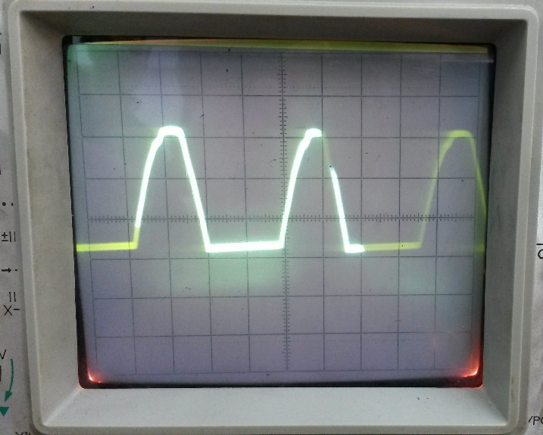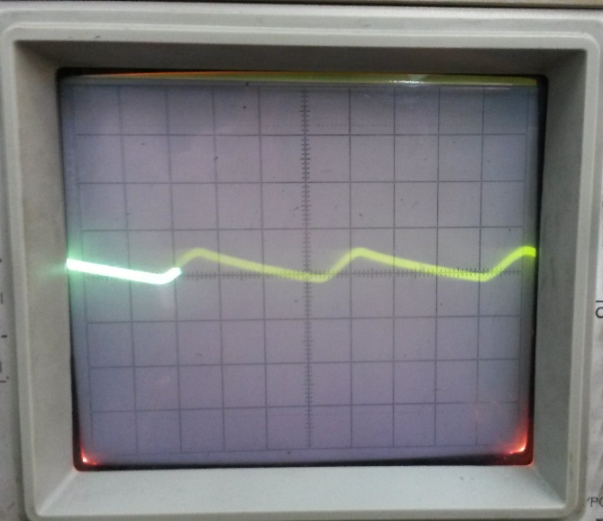

1. without filter
2. with filter C

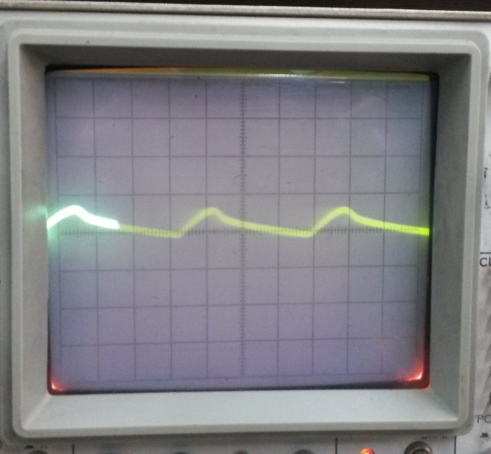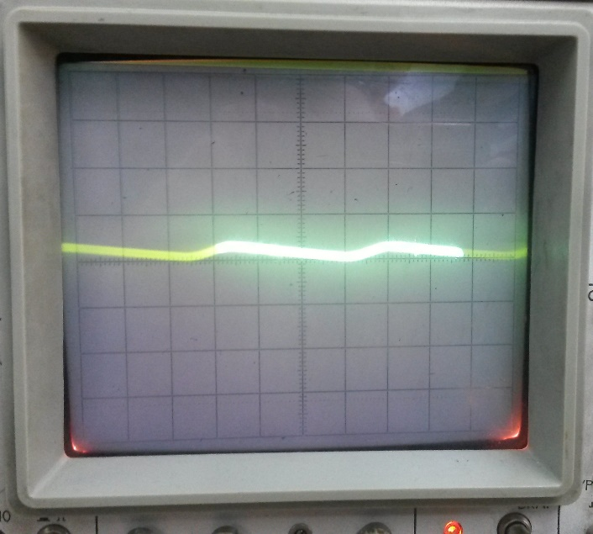

1. with RC filter
2. with CRC filter (π)

Full wave rectifier

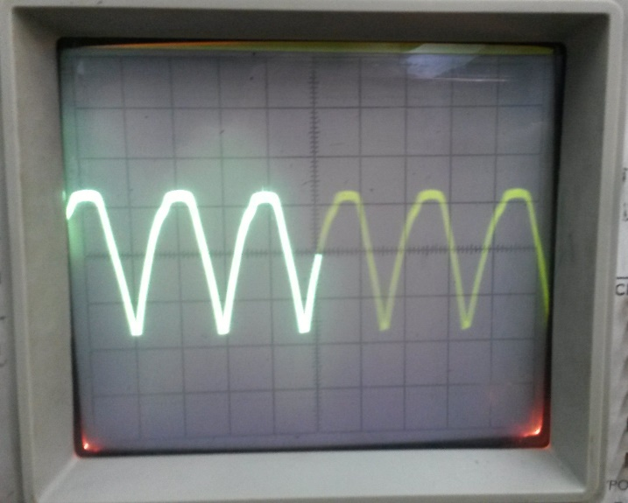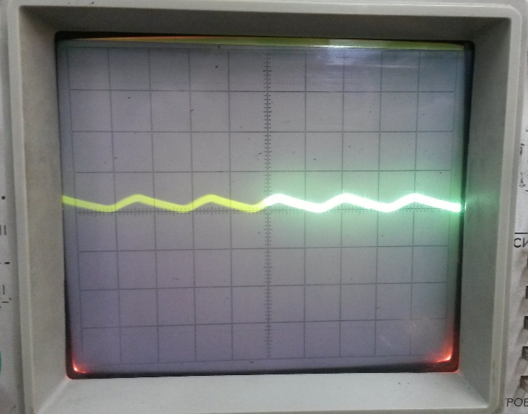

1. without filter
2. with filter C

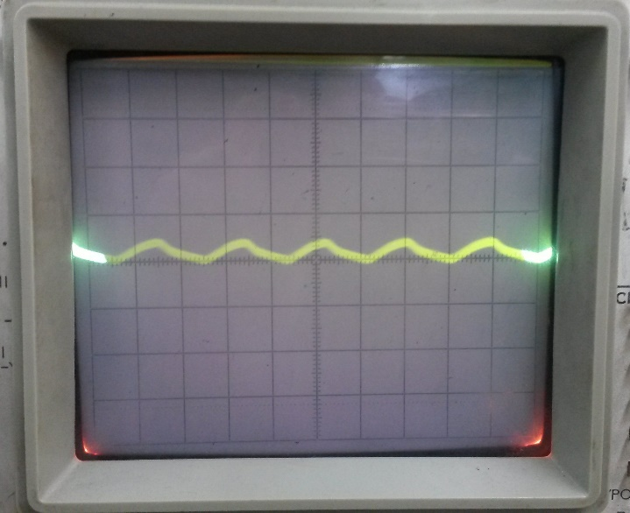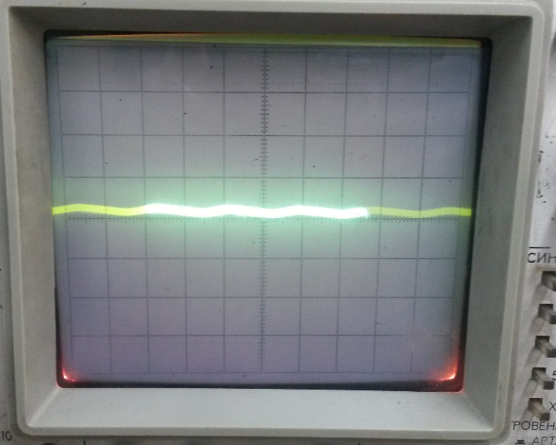

1. with filter RC
2. with filter CRC (π)

Bridge rectifier

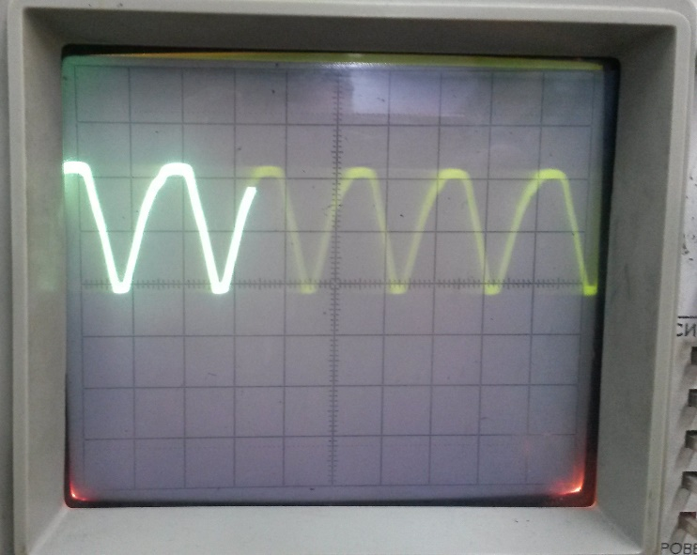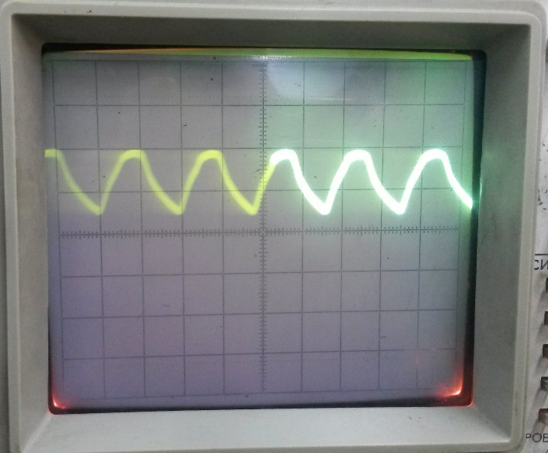

1. without filter
2. with filter C

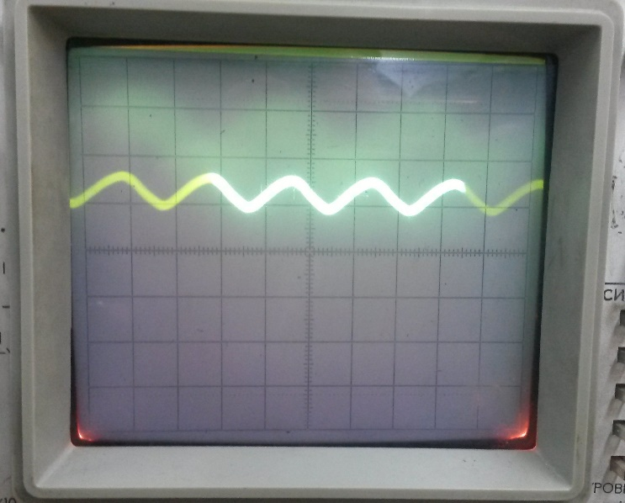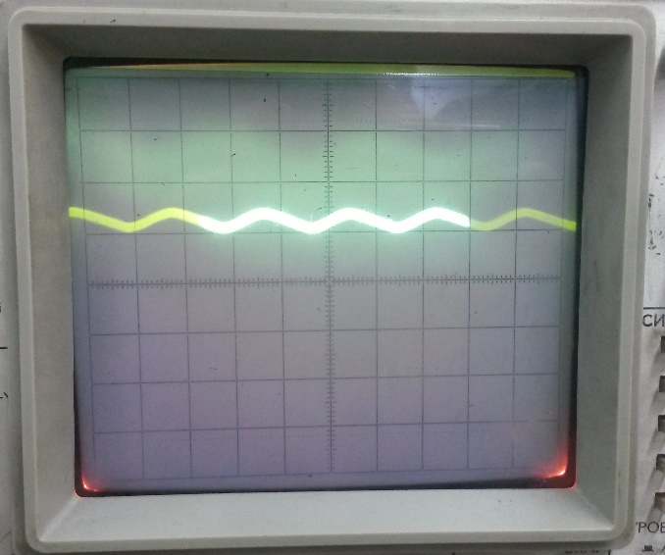

1. with filter RC
2. with filter CRC (π)